Ayesha Zubair
52916
Lab 8
Task 1:
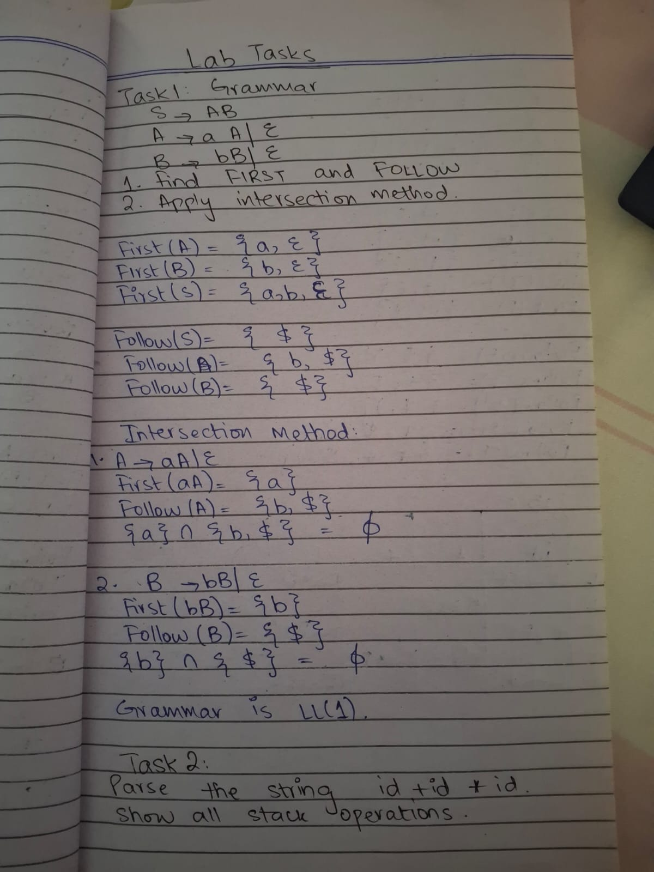
Task 2:
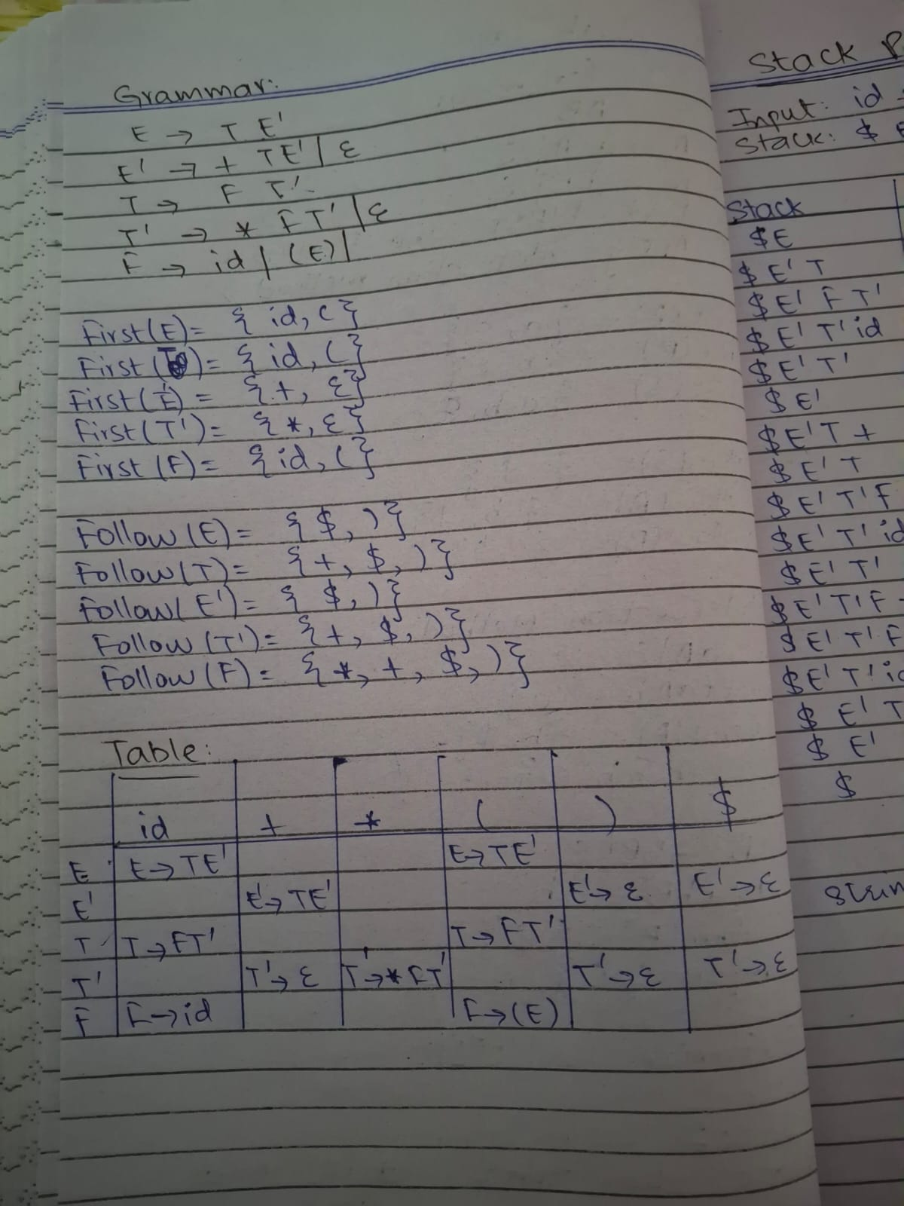
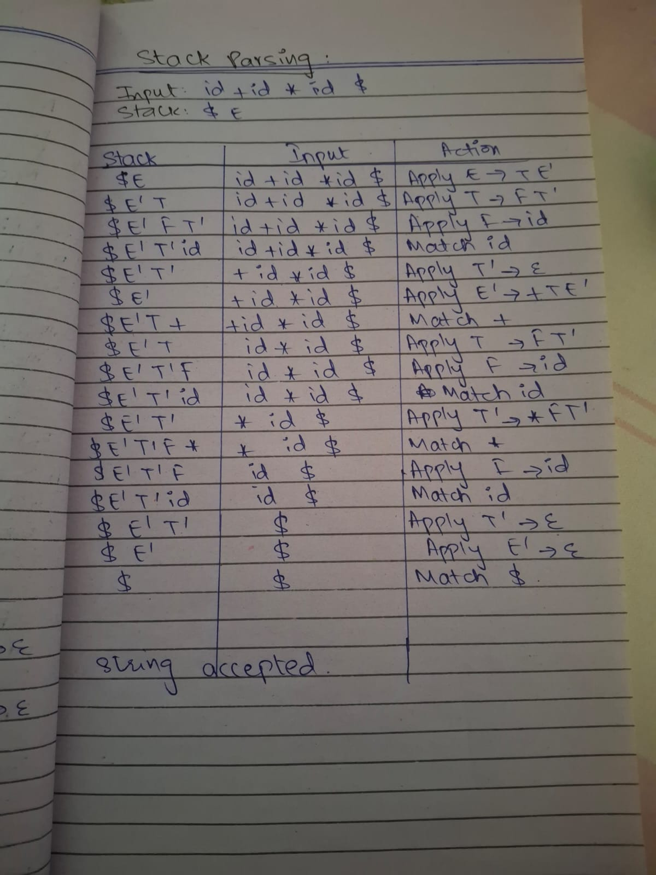

Task 3:
Code:
#include <iostream>
#include <string>
using namespace std;

string input;
int i = 0;

void error()
{
cout << "String Rejected (Syntax Error)" << endl;
exit(0);
}

void match(char c)
{
if (input[i] == c)
i++;
else
error();
}

void S(); // Function for non-terminal S

// S = a S b | e
void S()
{
if (input[i] == 'a')
{
match('a');
S();
match('b');
}

}

int main()
{
cout << "Enter input: ";
cin >> input;

S();

if (input[i] == '\0')
cout << "String Accepted" << endl;
else
cout << "String Rejected" << endl;

return 0;
}

Output:
